Samuel L. Morgan
December 7, 1904 – May 16, 1965

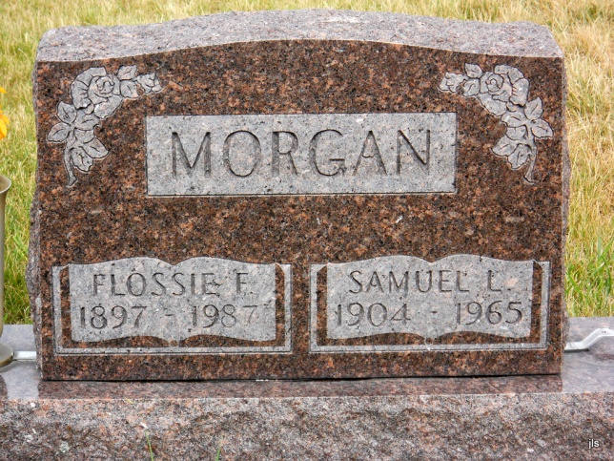
Photo by Jackie Sanders

Adams Public Library System (Decatur, IN) online obit abstracts
Publication: Decatur Daily Democrat; Date: 18 MAY 1965
Title: Morgan, Sam
Subject: Obituaries -- M -- 1960-1969
Abstract: Age 60
*****
Samuel L Morgan
in the Indiana, Death Certificates, 1899-2011
Name: Samuel L Morgan
Gender: Male; Race: White; Age: 60; Marital status: Married
Birth Date: 7 Dec 1904; Birth Place: Lawrence Co, Indiana
Death Date: 16 May 1965; Death Place: Decatur, Adams, Indiana, USA
Father: Albert Morgan; Mother: Rosetta York
Informant: Mrs. S. L. Morgan; wife; Willshire, Ohio
Burial: May 19, 1965; Alberson Cemetery, Geneva, Ind.

