Patricia Ann “Paddy” Patterson-Andorfer
March 14, 1934 – December 29, 1999

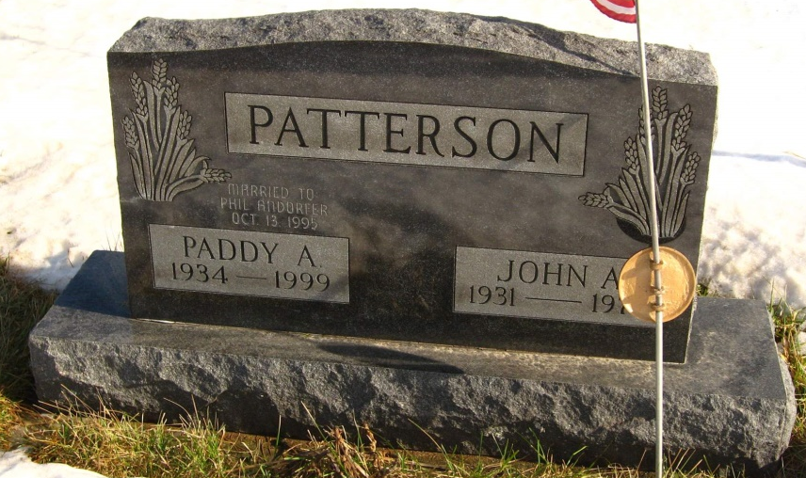
Photo by Tombstoner & Family

Patricia Ann "Paddy" Andorfer, 65, of Keystone, a retired teacher's aide, died Wednesday, Dec. 29, 1999, at Lutheran Hospital in Fort Wayne. The Columbus, Ohio, native retired in 1994 from Adams/Wells Special Services after 24 years of service; was a member of JT5 Home Economic Club and St. Joseph Catholic Church in Bluffton.
Surviving are her husband, Philip E.; a son, John G. Patterson of West Vancouver, Canada; daughters Kim Becher of Berne, DeAnn Hogston of Bluffton and Kelly Pearson of Attica; her mother, Diana
Macaluso Donavan of Sun City, Ariz.; a stepson, Paul A. of Albion; stepdaughters Amy Crabill and Mary Johnson, both of Churubusco, Sarah Simmions of Columbus City and Carol Andorfer of Fort Wayne; and 21 grandchildren. She was preceded in death by her first husband, John A. Patterson, and a son, Michael D. Patterson.
Services are 10 a.m. Friday at St. Joseph Catholic Church, Bluffton. Calling is from 3 to 8 p.m. today at Thoma-Rich Hewitt & Chaney Funeral Home, Bluffton. Burial will be in Alberson Cemetery.
Memorials are to the Diabetes Fund or Wells County 4-H Association.

News-Sentinel
December 30, 1999

