Merle Madaline (Holloway) Ropp
April 8, 1911 – April 9, 1936

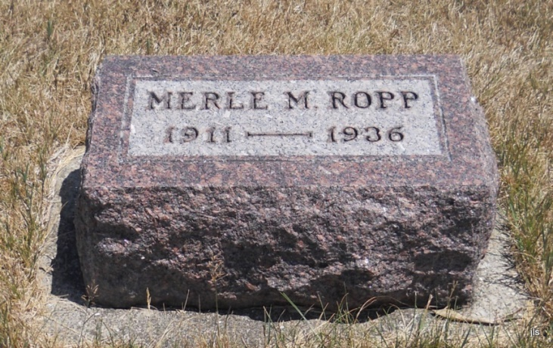
Photo by Jackie Sanders

ROPP

BLUFFTON, April 10 – Mrs. Merle M. Holloway Ropp, 25, is dead at the home of her parents, Mr. and Mrs. Caspar J. Holloway, one mile southeast of Petroleum, following an illness of two years.
Surviving are the parents; the husband, Harold Ropp; and three sisters, Mrs. Ralph Paxson, of Jay County, and Dolly Mae and Phyllis Joan Holloway, at home.
Funeral services will be held at 2 p.m. Saturday at the Gilead Church near Balbec and burial will be in the Alberson Cemetery.

Fort Wayne Journal-Gazette (IN); April 11, 1936, page 13

