Harold O. Runkel
September 4, 1906 – February 6, 1985

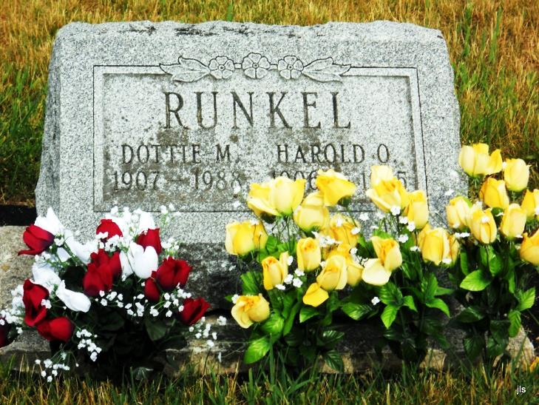

GENEVA –

Harold O. "Furpo" Runkel, 78, died Wednesday in Jay County Hospital, Portland.
Surviving are his wife, Dottie; five sons, including Robert L. of Fort Wayne; five daughters, and 42 grandchildren.
Services at 10:30 a.m. Saturday at Downing Funeral Home. Calling there from 2 to 5 and 7 to 9 p.m. today and from 9 a.m. Saturday.

Journal Gazette, Fort Wayne, IN; February 8, 1985, Page 2C

