Doris Erlene (Haines) Runyon
February 21, 1925 – June 16, 2013

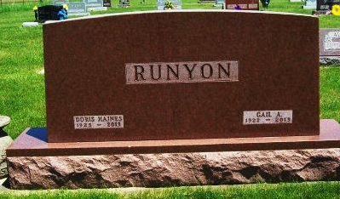
Photo by Scott Shoup

Doris Erlene Runyon, age 88, of 4100 West 1150 South, Geneva,
Indiana, passed away on Sunday, June 16, 2013 at Swiss Village in Berne. She was born at home in rural Berne, Indiana, to Earl and Elsie
(Harmon) Haines, married to Gail Alton Runyon on December 24,
1941. Both were lifelong farmers and owners of Runyon Farms in Adams County.
Preceded in death by husband Gail; she is survived by one son, David (Dawn); three daughters, Gaila (Ron) Crouch, of Tennessee, Gedda Starlin, of Geneva, Ginger (Jon) Roughia of Bryant; nine grandchildren and four greatgrandchildren and several nieces and nephews.
Funeral services will be private at the Baird-Freeman Funeral Home with Pastor Barry McCune presiding. Burial will follow in the Alberson Cemetery. Memorials can be made to Hospice of Northeast Indiana.

Baird-Freeman Funeral Home online obit (accessed June 17, 2013)

