Rachel Minerva (Hall) Runyon-Martz
March 23, 1866 – May 1, 1955

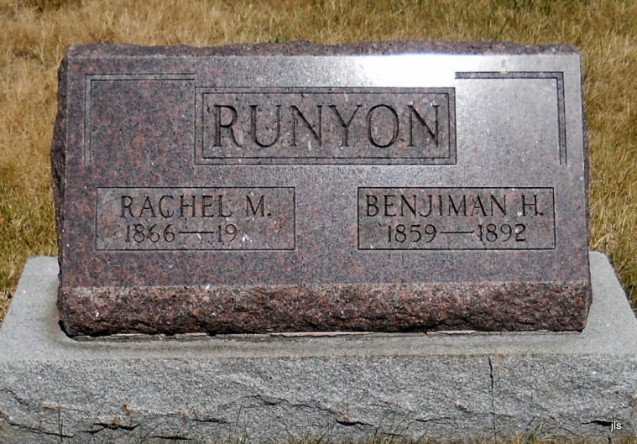

MRS. RACHEL MARTZ DIES EARLY SUNDAY
Funeral Services Tuesday Afternoon

Mrs. Rachel Martz, 89, a native of Adams County, died at 4:30 o'clock Sunday morning at the Haven Hubbard memorial home in New Carlisle, where she had resided since 1948. She had been in failing health since suffering a fractured hip in a fall in January.
Mrs. Martz was a member of the Bethany Evangelical United Brethren church in this city.
Surviving are a son, Roy Runyon of Decatur; a daughter, Mrs. Mabel Fuhrman of Syracuse; four stepsons, Coy Martz of Monroe, Thurman Martz of Dewey, Okla., Ira Martz of Avilla and Ferdinand Martz of Fort Wayne; a stepdaughter, Mrs. Bessie Wittwer of Vicksburg, Miss.; three grandchildren and nine great-grandchildren.
Funeral services will be held at 2 p.m. Tuesday at the Yager funeral home at Berne, the Rev. Benj. G. Thomas officiating, assisted by the Rev. Robert Schrock. Burial will be in the Alberson Cemetery southwest of Linn Grove. Friends may call at the funeral home until time of the services.

Decatur Daily Democrat, Adams County, IN; May 2, 1955

