Della Emaline (Fisher) Settle
March 3, 1886 – January 14, 1965

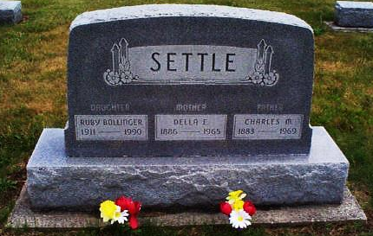
Photo by Mildred Ludy

MRS. SETTLE, 78, DIES; ILL 9 WEEKS

Mrs. Della Emaline Settle, 78, wife of Charles Settle, who resides two miles east and one mile south of Petroleum, died at 1:45 a.m. today at Clinic Hospital. She had been ill nine weeks. Born March 3, 1886 in Nottingham Twp., she was the daughter of Thomas and Elizabeth Dye Fisher. Her marriage to Mr. Settle took place Dec. 24, 1903 in Bluffton. A lifelong resident of Wells County, she was a member of the Phenix EUB Church.
Surviving, in addition to the husband, are two daughters, Mrs. Peter (Ruby) Bollinger of Geneva, and Mrs. Joe (Twylo) Elzey of Bluffton; two brothers, Ernest Fisher of Petroleum and Clyde Fisher of Shawnee, Okla. Eight step grandchildren, 26 great step grandchildren and one great-great step grand-child. Friends may call after 10 a.m. Friday at Thoma Funeral Home. Services will be held at 1:30 p.m., Saturday at the funeral home with Rev. Floyd Nevil officiating. Burial will be in Alberson Cemetery.

Bluffton News Banner, Wells County, IN; January 14, 1965

