Elizabeth (Alberson) Settle
April 28, 1850 – January 25, 1937

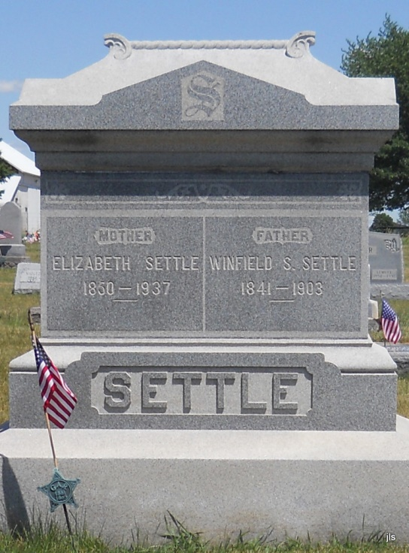

SETTLE

BLUFFTON, Jan. 25 –

Mrs. Elizabeth Settle, 86, died today at the home of a daughter, Mrs. Anna Wolfe, at Domestic.
Surviving children are William H. Settle, Petroleum; Rev. W. A. Settle, of Anderson; James E. Settle, of Mt. Pleasant, Mich.; Thomas J. Settle, Charles Settle and Walter Settle, all of Nottingham Township; Mrs. Anna Wolfe of Domestic and Mrs. George Templin of Bluffton. Four brothers surviving are Philip and Dennis Alberson, both of Nottingham Township; Jacob Alberson of Adams County, and Samuel Alberson, of Little Rock, Mo. Mrs. Settle was a member of the Phenix U. B. Church.

Journal-Gazette , Fort Wayne, IN; January 26, 1937, Page 17

