John P. Simmons
March 12, 1937 – October 3, 1997

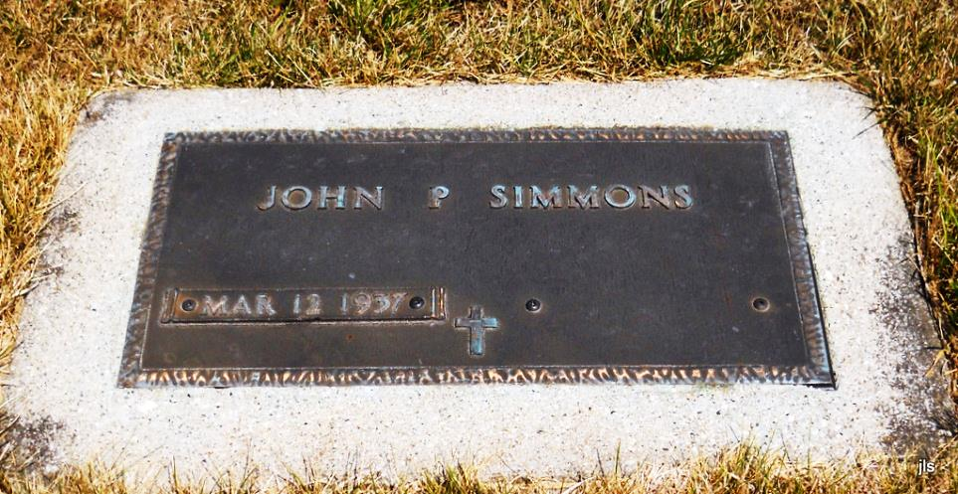

John P. Simmons, of Indianapolis, formerly of Geneva, died Friday at I.U. Medical Center. The Geneva native was a retired cook.
Surviving is a companion, Gordon Couch, of Indianapolis.
Graveside services are at 10 a.m. Monday at Alberson Cemetery, Geneva. There is no calling.
Memorials are to the American Diabetes Association. Arrangements by Downing Funeral Home, Geneva.

News Sentinel, Fort Wayne, IN; October 4, 1997

