Mabel Eileen Taylor
April 12, 1919 – September 28, 2005
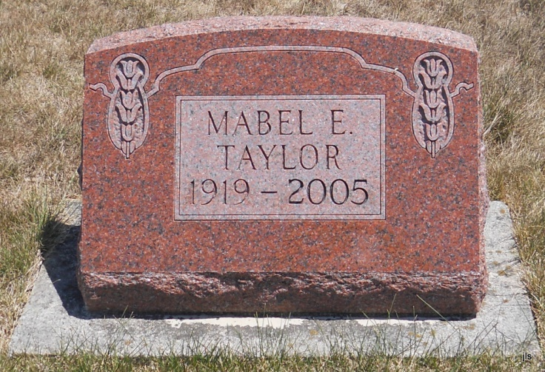
Photo by Jackie Sanders

Mabel Eileen Taylor, 86, died Wednesday, Sept. 28, 2005, at Golden Years Homestead, Fort Wayne. Born in Wells County, she was a Client Service Correspondent with Lincoln Life Insurance Company for 43 years, retiring in 1981. She was a member of Christ Church at Georgetown, where she was the trip chairman for the Voyagers Senior Group for 20 years.
Survivors include cousins, Rosie Duffy of Indianapolis, Ray Zell of Fort Wayne, Connie Dixon of Flint, Mich., Gary Zell of Grant Park, Ill., Jim Taylor of Anderson, Larry Woods of San Francisco, Calif. and Stanley Woods of Phoenix, Ariz.; several other cousins; and special friends, Faye and Dan Harlow, Paul and Gloria Smith, Ruth Holley, and Barb Eisberg. She was preceded in death by parents, Earl and Minnie Taylor; and sister, Melba Taylor.
Service is 11 a.m. Monday at D.O. McComb & Sons Maplewood Park Funeral Home, 4017 Maplecrest Road, with calling one hour prior; Dan Harlow officiating. Calling is from 5 to 7 p.m. Sunday at the funeral home. Burial in Alberson Cemetery, Petroleum. Memorials to Christ Church at Georgetown.

Fort Wayne News-Sentinel (IN); October 1, 2005

