Isaac E. Sarg
January 14, 1846 – February 28, 1914

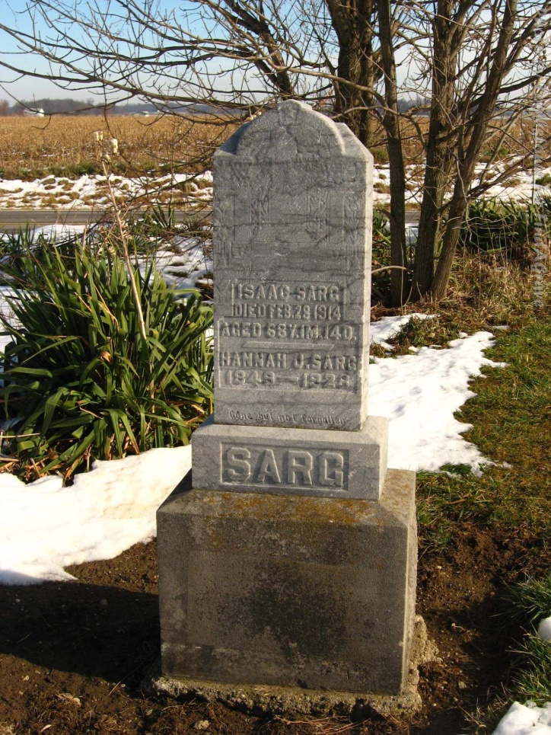
Photo by Tombstoner & Family

SARG FUNERAL WEDNESDAY

The funeral of Isaac E. Sarg, aged 68 years, whose death occurred Saturday at his home two miles east and a mile and three-quarters south of Petroleum, will be held at 10 o'clock Wednesday morning at the Phoenix church with burial in the Alberson cemetery.
Isaac E. Sarg was born January 14, 1846, in Adams county, and on March 7, 1875, married Hannah J. Huffman, of Adams county. To their union six children were born, five of whom are living. Those living are William, Noah, John, Cora and Harry. Jennie, the daughter, died several years ago. Mr. Sarg has made his home in the location where his death occurred, for many years and he was highly respected by the community surrounding.

Bluffton Banner, Wells County, Indiana; Monday, March 2, 1914

Contributed by Karin King

