Evert Ray Anspaugh
June 11, 1907 – March 8, 1908

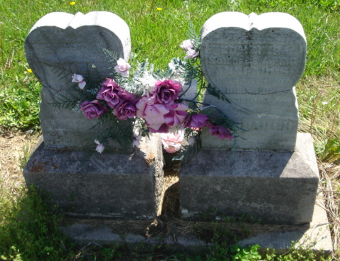
Photo by Cousin Becky

No obit found at this time

