Mary Ann (Martin) Brewster
January 28, 1822 – February 9, 1895
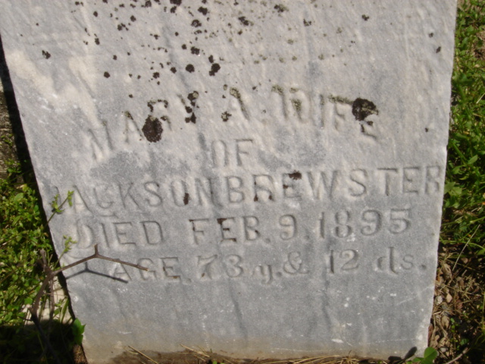
Photo by Cousin Becky

No obit found at this time

