Sarah A. (Fetters) Brewster
January 4, 1849 – November 1, 1876
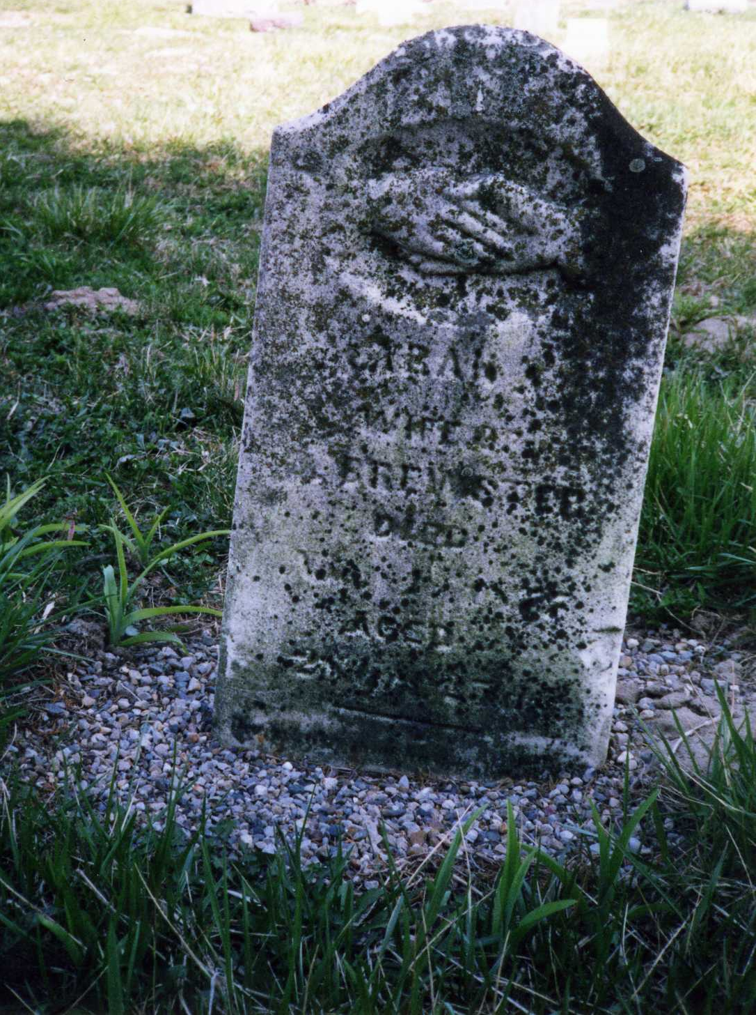
Photo by Dave Buckmaster

No obit found at this time

