Peter Jennings Bryan
May 22, 1852 – January 26, 1914
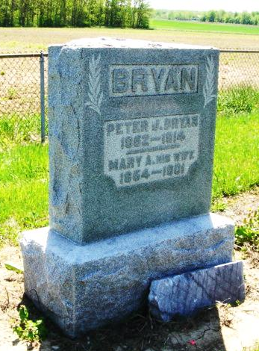
Photo by Cousin Becky

Adams Public Library System (Decatur, IN) online obit abstracts
Publication: Decatur Daily Democrat; Date: 29 JAN 1914
Title: Bryan, Peter J.
Subject: Obituaries -- B -- 1910-1919
Abstract: Age 62
Died: Tuesday, January 27, 1914

