Mary Buckmaster
October 15, 1863 – May 26, 1880
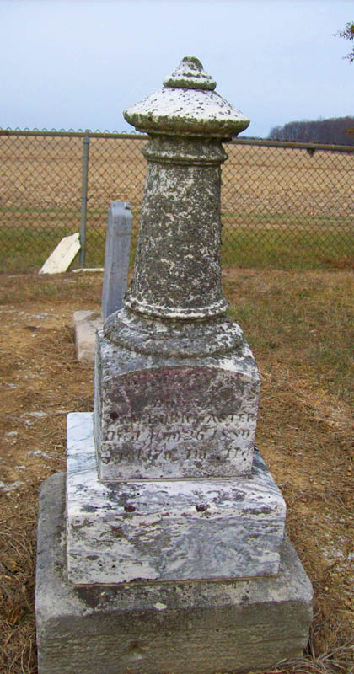
Photo by Dave Buckmaster

No obit found at this time

