Eliza J. Berdg
May 4, 1840 – July 6, 1852
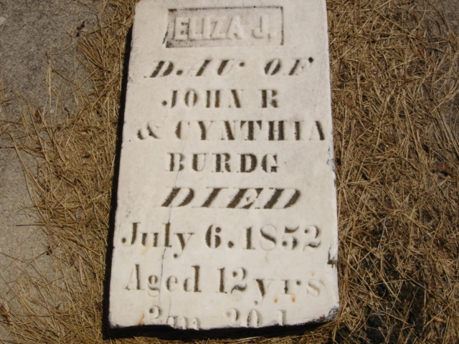
Photo by Cousin Becky

No obit found at this time

