Keith Charleston
1927 - 1930
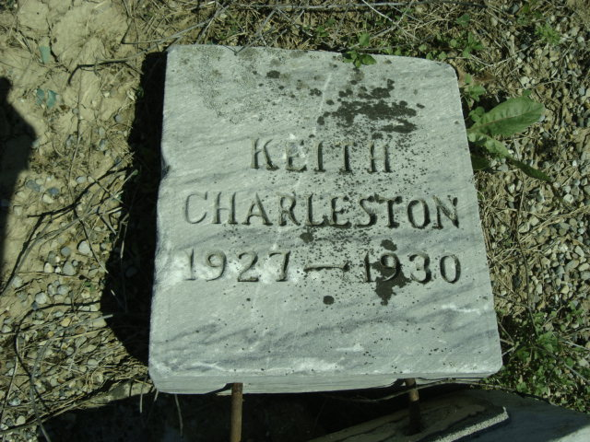
Photo by Cousin Becky

No obit found at this time

