Mary A. Duer
March 2, 1874 – July 25, 1874
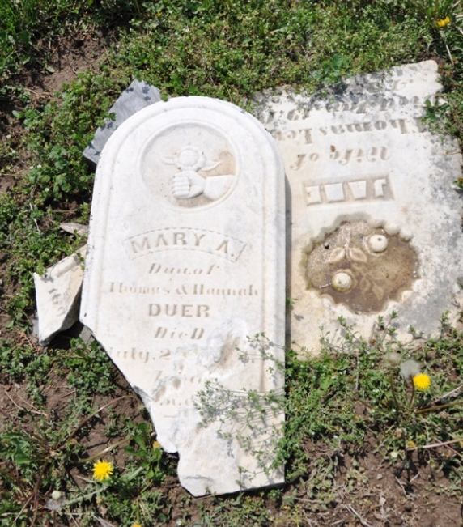
Photo by Deb Curry

No obit found at this time

