Theodore Fetters
August 8, 1872 – February 11, 1926
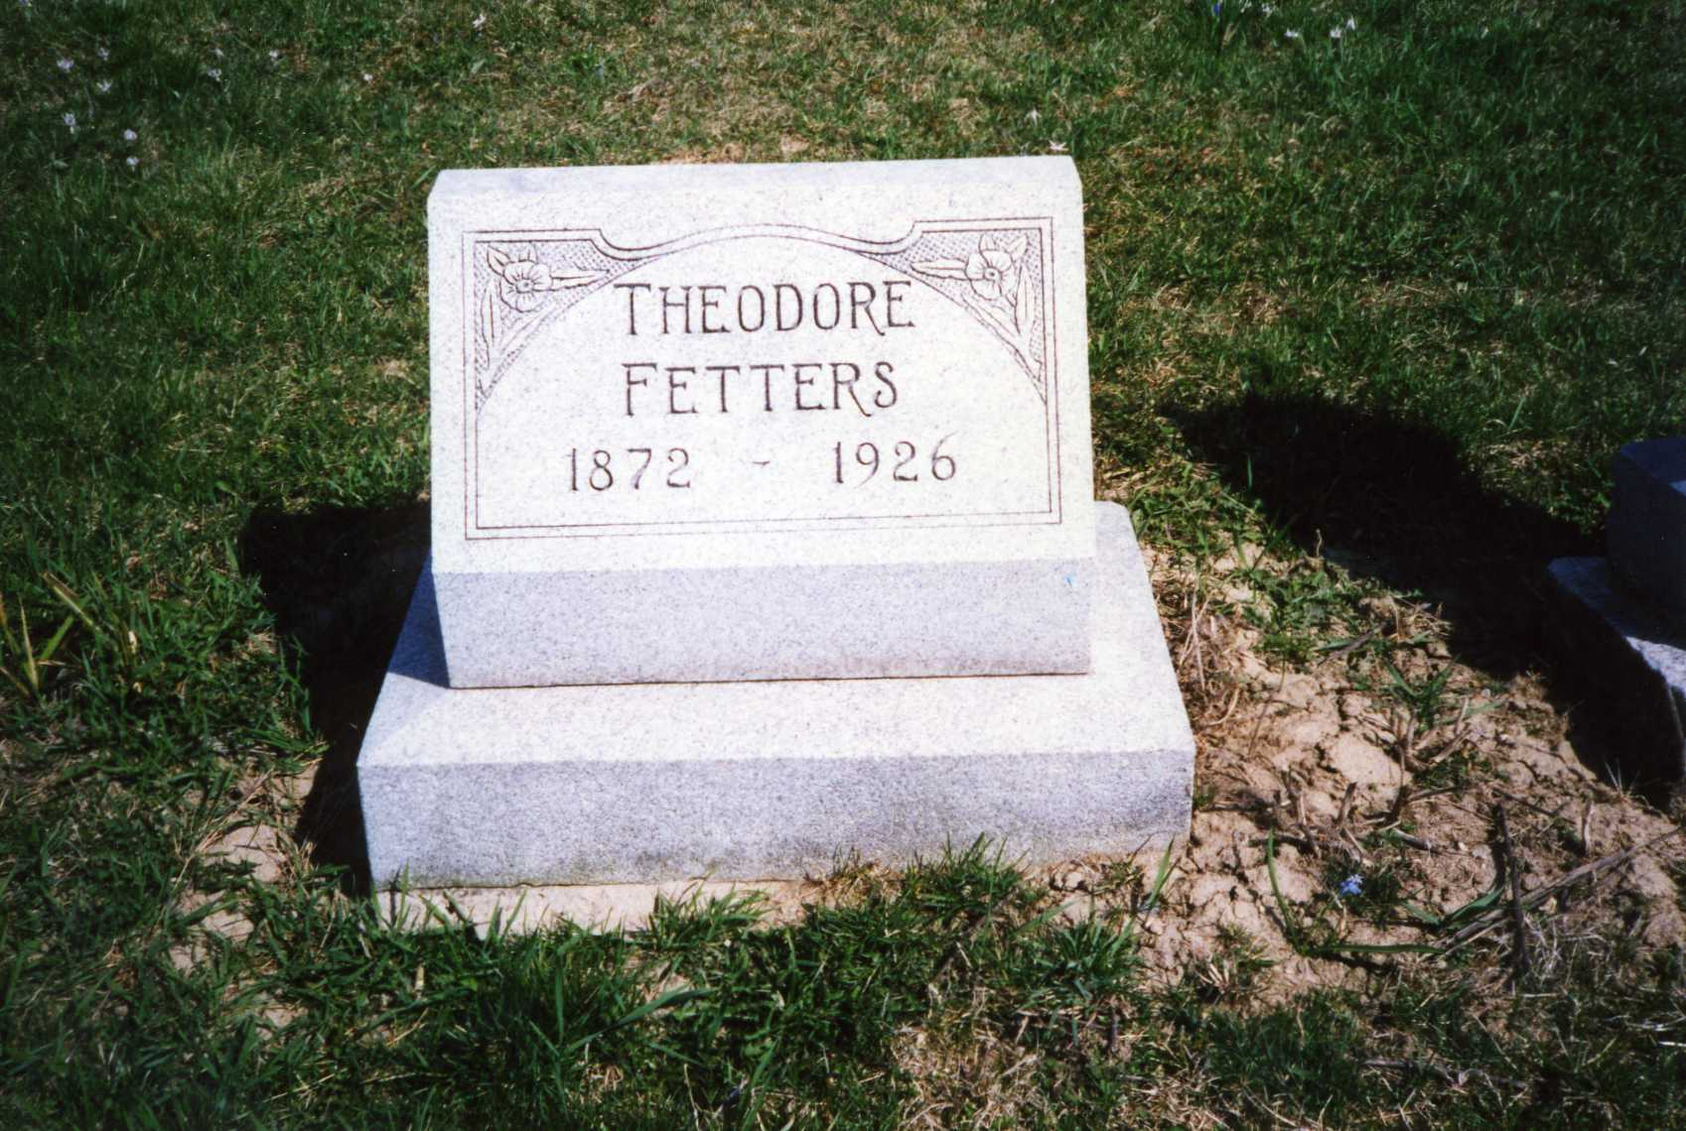
Photo by Dave Buckmaster

No obit found at this time

