Dr. Lewis C. Finley
July 9, 1826 – October 10, 1859
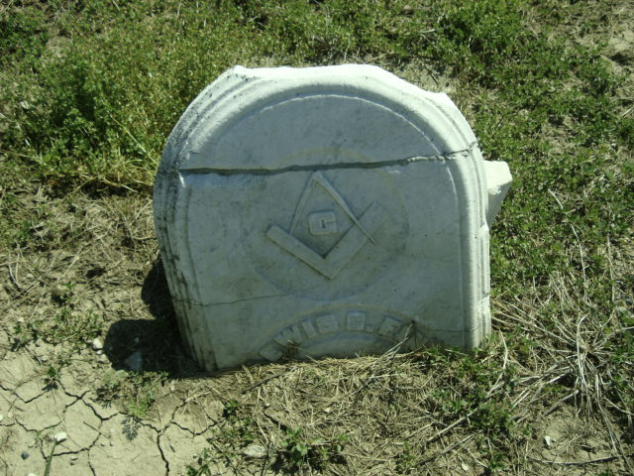
Photo by Cousin Becky

No obit found at this time

