Barbra E. Fogle
October 8, 1821 – December 22, 1909
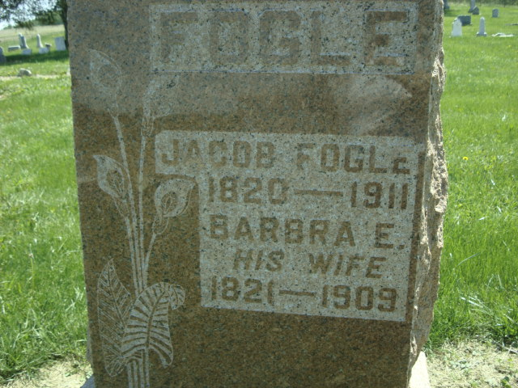
Photo by Cousin Becky

No obit found at this time

