Sarah (Fravel) Fogle
October 17, 1848 – March 15, 1907
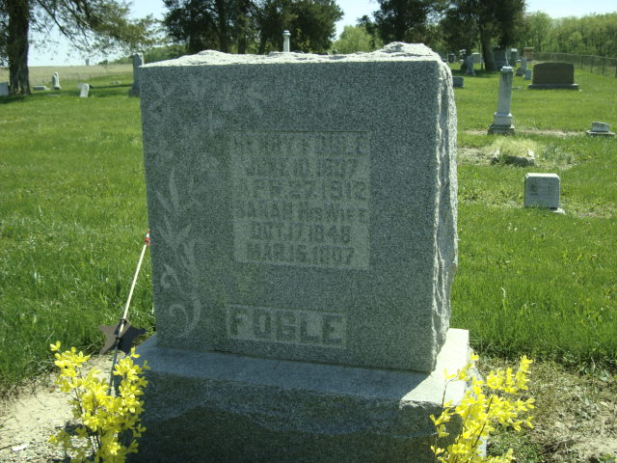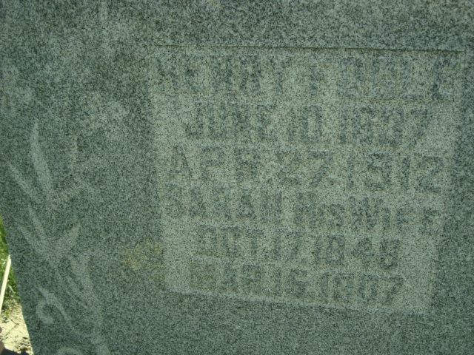
Photo by Cousin Becky
No obit found at this time

