Mary B. (Shephard) Hall
January 3, 1810 – September 28, 1875
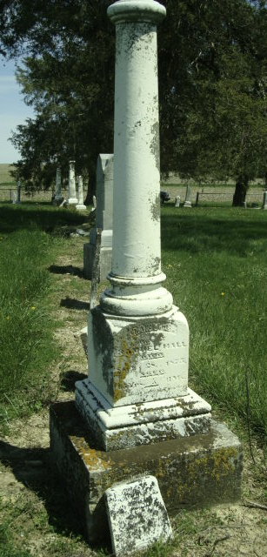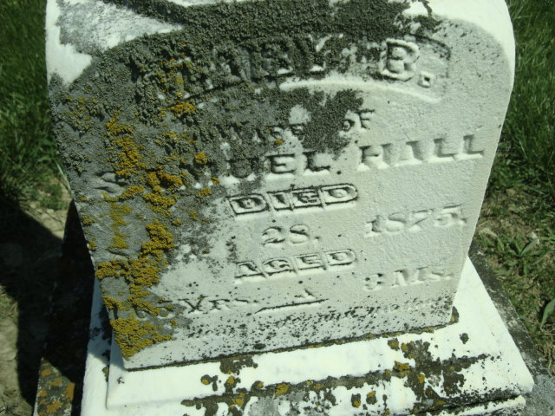
Photo by Cousin Becky

No obit found at this time

