William A. Hall
September 2, 1838 – November 3, 1870
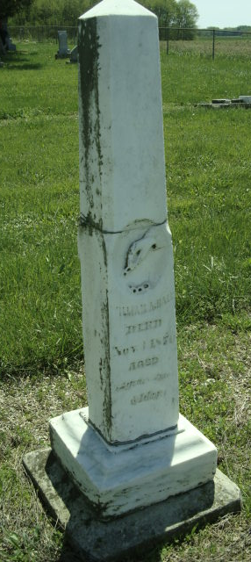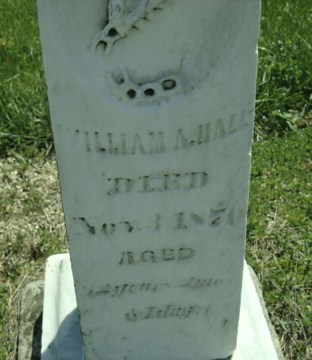
Photo by Cousin Becky

No obit found at this time

