Louisa Heimbarger
February 24, 1830 – April 6, 1903
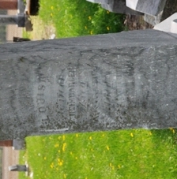
Photo by Deb Curry

No obit found at this time

