Franklin Hisey
February 2, 1860 – May 15, 1938
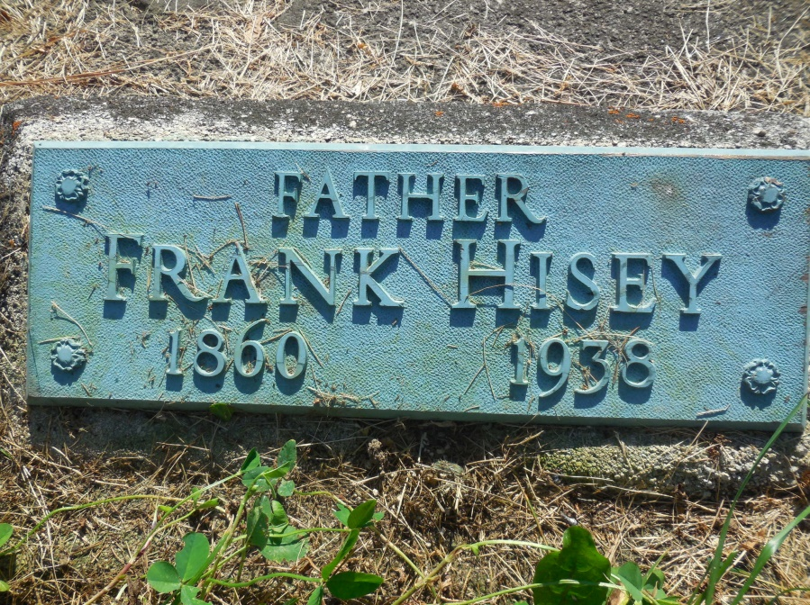
Photo by Cousin Becky

No obit found at this time

