Isabelle (Hutchinson) Hutchison
October 17, 1796 – September 17, 1869
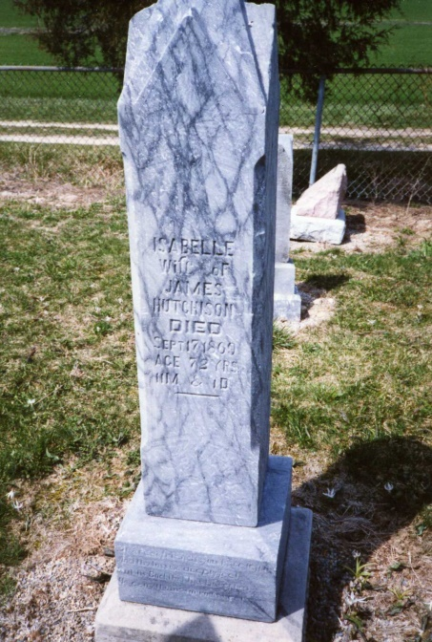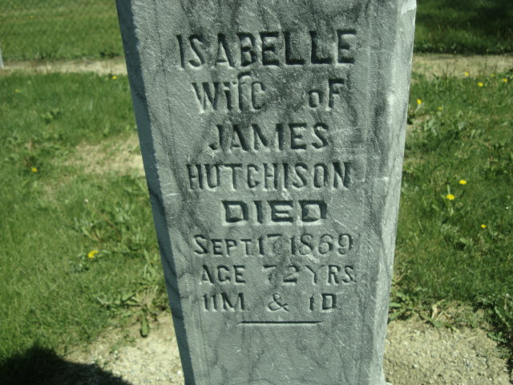
Photo by Dave Buckmaster & Cousin Becky

No obit found at this time

