Jonathan Augustus Kelly
1860 – April 11, 1899
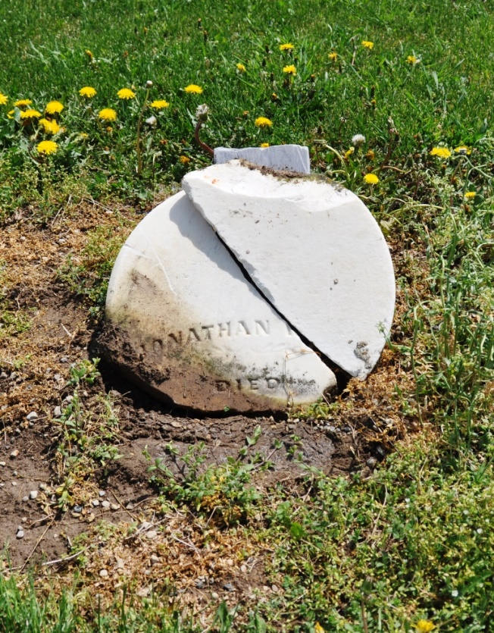
Photo by Deb Curry
No obit found at this time

