Hannah D. Lewis
May 14, 1854 – December 25, 1860
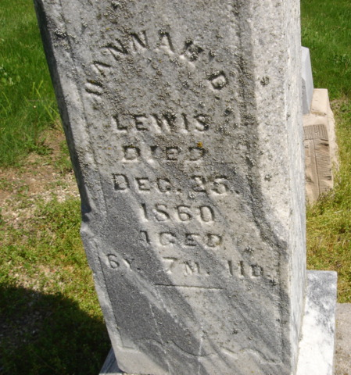
Photo by Cousin Becky
No obit found at this time

