Mary Loofbourrow
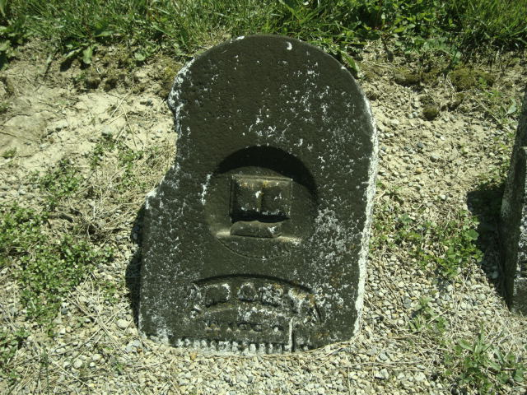
Photo by Cousin Becky
No obit found at this time

