Wade Davis Loofbourrow
February 20, 1788 – April 29, 1857
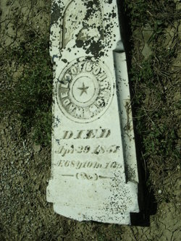
Photo by Cousin Becky
No obit found at this time

