Ohio J. Searight
1869 – July 20, 1871
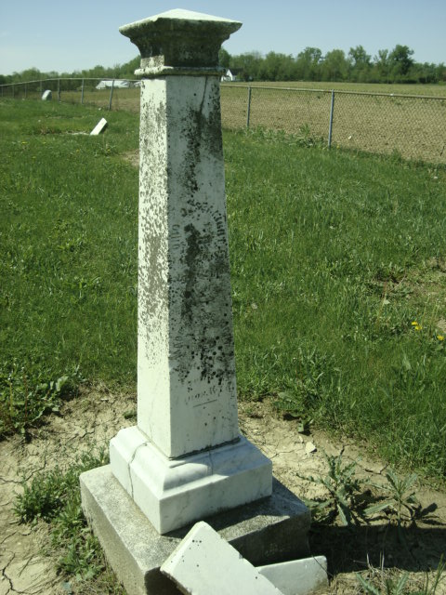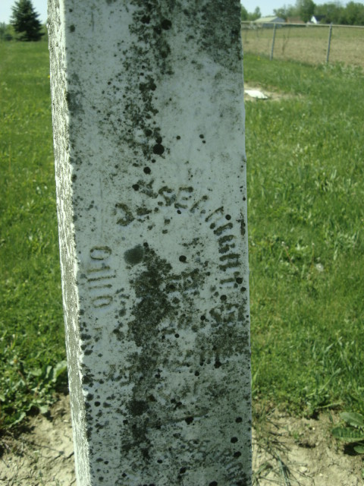
Photo by Cousin Becky
No obit found at this time

