William Henry Wade Walter
January 7, 1855 – September 12, 1855
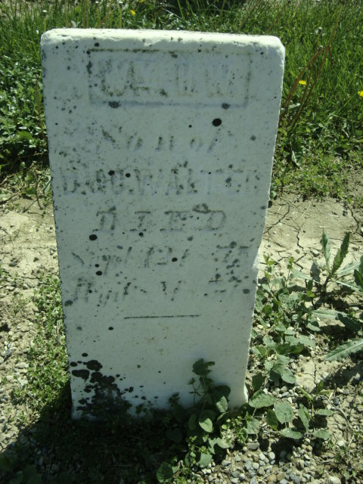
Photo by Cousin Becky
No obit found at this time

