Samuel H. Weist
March 20, 1873 – November 12, 1874
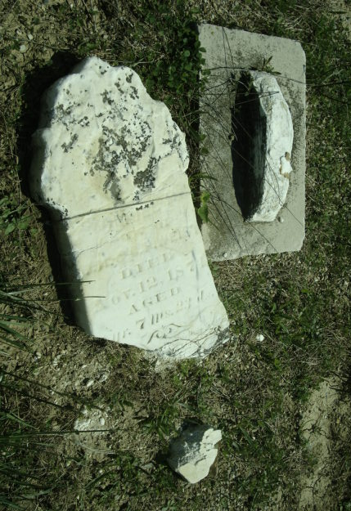
Photo by Cousin Becky
No obit found at this time

