Segar H. Young
- June 13, 1866
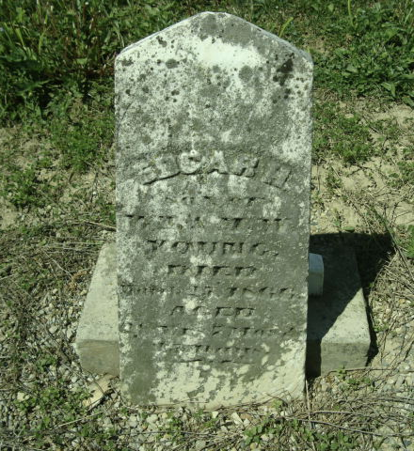
Photo by Cousin Becky
No obit found at this time

