Anthony S. Brinksneader
April 17, 1902 – August 26, 1977

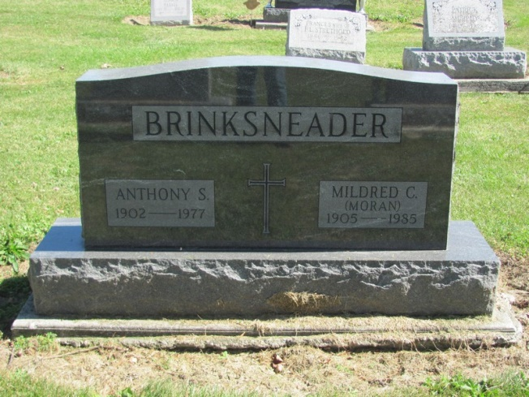
Photo by Jenna Langston

Adams Public Library System (Decatur, IN) online obit abstracts
Publication: Decatur Daily Democrat; Date: 27 AUG 1977
Title: Brinksneader, Anthony S.
Subject: Obituaries -- B -- 1970-1979
Abstract: Age 75
Born: April 17,1902 in Chrisney, IN
Died: Friday, August 26,1977
Married: Mildred C. Moran in 1942
Notes: DPL Scrapbook 4-203-

