Harold “Bud” Cleveland
August 30, 1924 – March 7, 2001

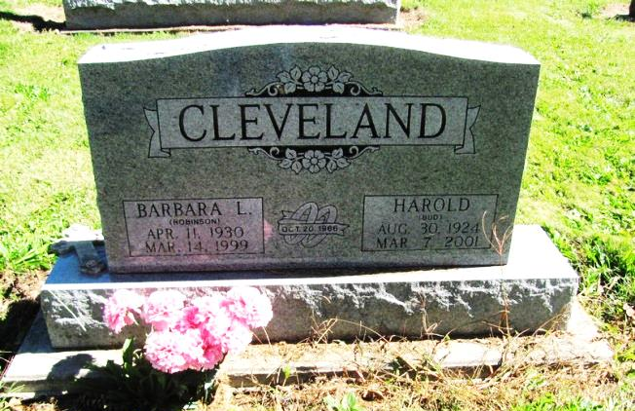
Photo by Jenna Langston

Harold "Bud" Cleveland, 76, of Geneva, a native of Fort Wayne, died Wednesday, March 7, 2001, at home.
He retired in 1985 from Cummings Mid State Power in Fort Wayne and had also worked for ABC Coach Lines in Fort Wayne from 1965 to 1976.
Surviving are sons Brent M. of Fort Wayne and Jeffery J. of Tampa, Fla.; a daughter, Dawn of Fort Wayne; and three grandchildren. He was preceded in death by his wife, Barbara.
Graveside services are 11 a.m. Saturday at St. Mary's Catholic Cemetery, Geneva. There is no calling.

News-Sentinel, Fort Wayne, IN; March 9, 2001

Contributed by Jane Edson

