Patrick Fahey
1838 – June 17, 1916
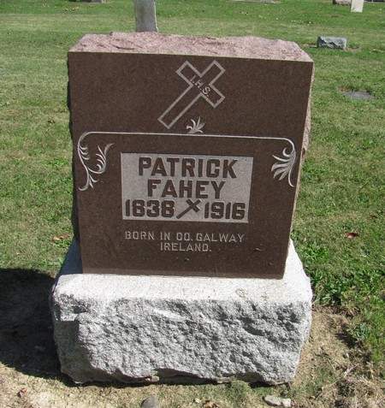
Photo by Jenna Langston

Adams Public Library System (Decatur, IN) online obit abstracts
Publication: Decatur Daily Democrat; Date: 21 JUN 1916
Title: Fahey, Patrick
Subject: Obituaries -- F -- 1910-1919
Abstract:

