Edward Joseph Kenney
1863 – July 22, 1945
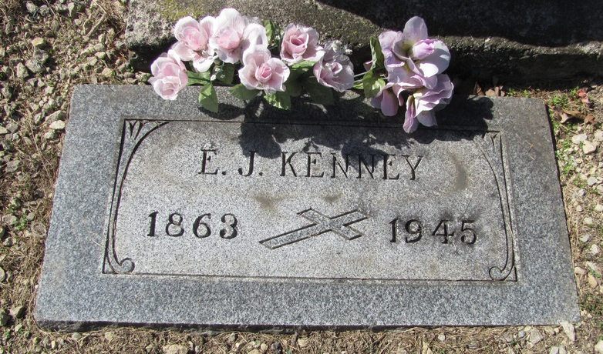
Photo by Jenna Langston

EDWARD J. KENNEY IS TAKEN BY DEATH
Former Resident of New Corydon Dies

Edward Joseph Kenney, 82, a former store proprietor and resident of New Corydon (Kenney Settlement), died last evening at St. Joseph's Hospital, Fort Wayne, of complications.
Mr. Kenney was born in Cincinnati, but spent most of his life in Adams County, retiring from the mercantile store and farming business several years ago. He moved to Fort Wayne seven years ago.
Surviving are the widow, Mary Ann Kenney, and three granddaughters, Mrs. Justin E. Arata, the Misses Etta and Marjorie Welsch and a son-in-law, Henry Carson Welsch.
The body has been moved to the Tom Mungovan Funeral Home, 2221 South Calhoun Street, Fort Wayne. Funeral services have not been arranged. Burial will be in St. Mary's Catholic Cemetery, east of Geneva.

Decatur Daily Democrat, Adams County, IN; July 23, 1945

Contributed by Karin King

