Mary Helen Kenney
1899 – January 31, 1991
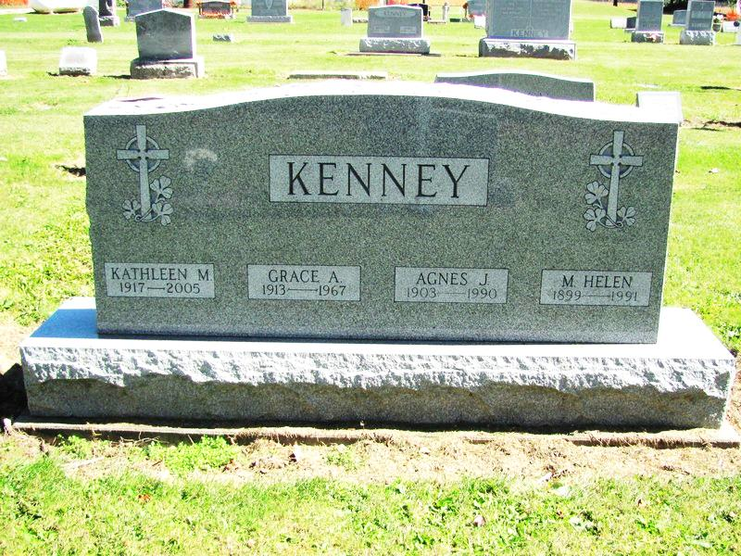
Photo by Jenna Langston

Helen Kenney, 91, died yesterday at Celina Manor Nursing Home, Celina. She was a former Geneva resident and a retired schoolteacher.
Surviving are a sister and four nephews.
Calling will be from 8:30 to 9:30 a.m. tomorrow at Downing Funeral Home, Geneva.
Services will be held at 10 a.m. tomorrow at St. Mary's Catholic Church, Geneva. Burial will be in the church cemetery. Preferred memorials are gifts to the church.

News-Sentinel, Fort Wayne, IN; February 1, 1991

Contributed by Jane Edson

