Michael D. Kenney
1813 – August 7, 1901

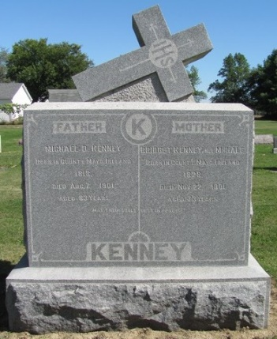
Photo by Time Out of Mind

Michael D. Kenney, known more favorable to a large number of Adams County citizens at Kinney in the hollow, and one of the early pioneers of old Jefferson Township, died at his country home there last Monday afternoon. His death was caused by the result of a fall received a week previous, and which dislocated his hip joint. Owing to his advanced age the shock was too severe and his death resulted. The deceased was born in the county Mayo, Ireland, in the year 1813, and had lived in Jefferson Township forty-four years, coming there from Cincinnati. At that time he was penniless, but after forty-four years of frugality, hard labor and a generosity that is unequalled, he leaves an estate that ranks him as one of the wealthiest men in Jefferson Township.
He leaves a widow and three sons, James, the trustee of Jefferson Township, and John and Patrick who are lawyers of considerable repute, living in Celina, Ohio.
The funeral took place last Friday from the St. Mary's Catholic Church in Jefferson Township, with interment in the cemetery by the church. His death removes a landmark and one of the best known, most generous and charitable citizens of Jefferson Township or of the county.

Decatur Daily Democrat, Adams County, Indiana
August 15, 1901

