Edgar M. LaFontaine
August 21, 1899 – April 28, 1937
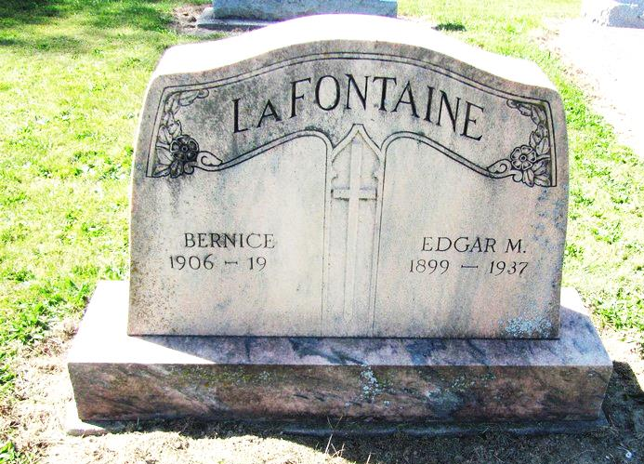
Photo by Jenna Langston

(Handwritten date: Thursday, April 29, 1937)

OFFICIAL OF EASTERN IND. OIL CO. DIES
Edgar M. LaFontaine, Aged 37, Dies at Home From Paralysis

Edgar M. (Casey) LaFontaine, aged 37, vice president and director of the Eastern Indiana Oil & Supply Co. of Geneva, died at his home at New Corydon, at 4:30 o'clock Wednesday morning. Death was due to a stroke of paralysis suffered by Mr. LaFontaine on Apr. 15.
Mr. LaFontaine was well known in Berne as he visited at the local branch of the Eastern Indiana Company many times. He was born in Jay County, August 21, 1899.
Surviving are the widow, his mother-in-law, his mother, Mrs. Theresa LaFontaine of Fort Wayne and the following seven brothers: H. P. LaFontaine, superintendent of the Adams County infirmary; R. N. LaFontaine, Fort Wayne; L. P. LaFontaine, Sparrow Lake, Iowa; Clarence, Erie, Pa.; Sylvester, Ft. Wayne; Frederick, Milford, Iowa; and Walter, Erie, Pa.
The funeral will be at 9 o'clock Saturday morning at the St. Mary's Catholic Church seven miles east of Geneva. Burial will be in the church cemetery.

Adams County Historical Museum
1937 Scrapbook
Transcribed by Karin King

