Victor Henry Laux
December 29, 1915 – December 1, 2013
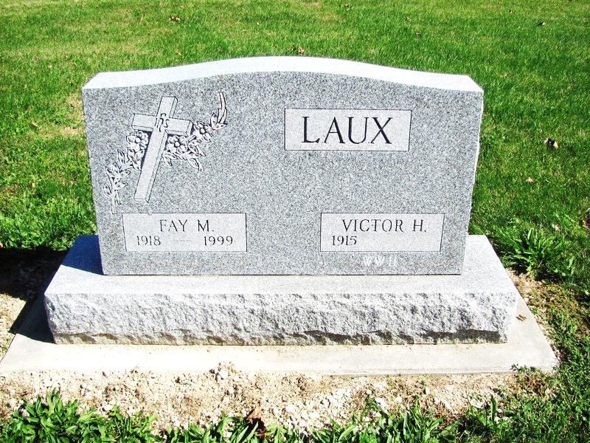
Photo by Jenna Langston

Victor Henry Laux, 97, of Geneva, IN, passed away at 12:55 PM on Sunday, December 01, 2013 at Chalet Village Health & Rehabilitation in Berne, IN. He was born on Wednesday, December 29, 1915, in Bryant, IN. He married Fay Weaver on October 11, 1940; she passed away on December 5, 1999. Victor was a U.S. Army Veteran, serving during WWII in the European Theater of Operations. Victor was a member of the Decatur American Legion Post#43. He retired from GE in Decatur in 1976, after 20 years of service. Victor was a member of the St. Mary of The Presentation Parish in Geneva.
Survivors include: Son - Larry (Wife, Nancy) Laux, Berne, IN., Daughter – Janet (Husband, Tony) Lengerich, Decatur, IN, 9 grandchildren, 23 great grandchildren, 5 great-great grandchildren, Sister - Sister Rosie Laux, Salem Heights, OH, Sister – Esther Frisbie, St. Mary’s, OH. He was preceded in death by his: Father - Joseph Laux, Mother - Frances (Wellman) Laux, Wife – Fay (Weaver) Laux, Brothers - Eugene Laux, Ray Laux, Joe Laux, Sisters – Sister Agnes Laux, Helen Montgomery and Bernice Eichelberger.
Family and friends may gather to share and remember at Downing & Glancy Funeral Home 100 N Washington Street Geneva on Wednesday, December 04, 2013 from 3:00 p.m. to 8:00 p.m. and from 9:00 a.m. to 9:45 a.m. at Downing & Glancy Funeral Home Thursday, December 05, 2013, before the service.
Mass will be held at the St. Mary's of the Presentation Church 5790E. – 1100 S. Geneva at 10:00 a.m. on Thursday, December 05, 2013 with Father J. Bosco Perera officiating. Interment will follow in the St. Mary's Presentation Catholic Church Cemetery in Geneva.
Preferred memorials: St. Mary’s Presentation Catholic Church Building Fund 5790 E. – 1100 S. Geneva, IN 46740
Arrangements are being handled by Downing & Glancy Funeral Home in Geneva.
Downing & Glancy Funeral Home online obit (accessed December 2, 2013)

