Robert Thomas Moran
1907 – May 1, 1979
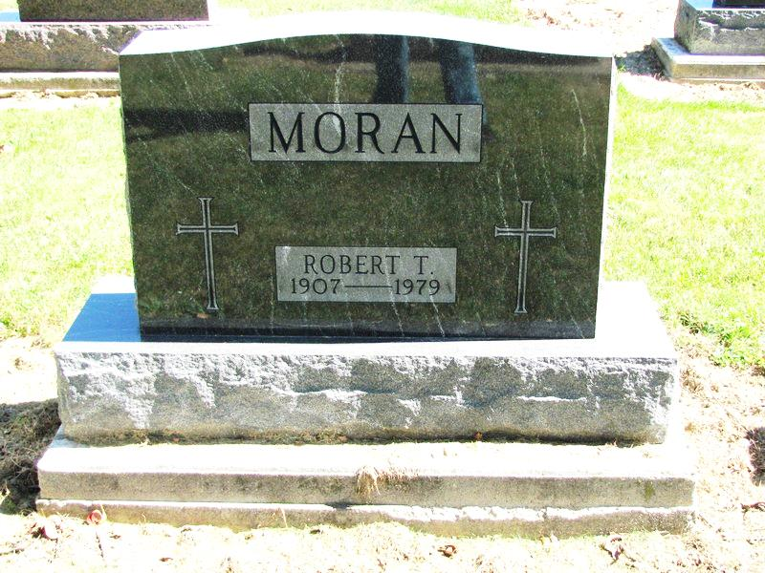
Photo by Jenna Langston

Adams Public Library System (Decatur, IN) online obit abstracts
Publication: Decatur Daily Democrat; Date: 02 MAY 1979
Title: Moran, Robert Thomas
Subject: Obituaries -- M -- 1970-1979
Abstract: Died: Tuesday, May 1, 1979
Notes: DPL Scrapbook 5 page 85

