Robert John Otto, IV
December 30, 1990 – July 20, 2004
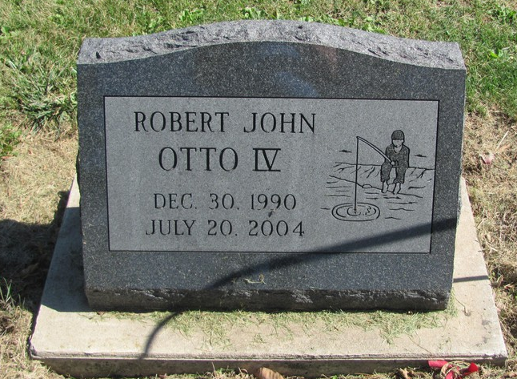
Photo by Jenna Langston
Robert J. Otto IV, 13, of 11080 North State Road 1, Ossian, died at 1:54 a.m. Tuesday, July 20, 2004, at Lutheran Hospital in Fort Wayne.
He would have been an eighth grader this coming year at Norwell Middle School, where he also played football. He was a member of St. Aloysius Catholic Church at Yoder.
Robert was born Dec. 30, 1990 in Wells County to Robert J. Otto III and Gina Christy Vinci.
Surviving are his father and stepmother, Robert and Lora Otto of Ossian; his mother and stepfather, Gina Vinci of Indianapolis and Vincent Vinci, stationed in Korea with the U.S. Army; one brother, David Vinci of Indianapolis; two sisters, Becca and Angela Vinci of Indianapolis; grandparents Robert Jr. and Audrey Otto of Indianapolis, Michael and Sonja Kelly of Berne, Bernadette and Ronald Reisinger of Fort Wayne, John and Susan Graves of Brownsville, Indiana, Kent Christy of Indianapolis and Stephen Deuser of Carmel, and great-grandparents Robert Sr. and Rose Otto of Crystal Falls, Mich., Bryce and Deloris Christy of Berne, Jack and Betty Stahley of Portland and Cedric and Margaret McAbee of Portland.
Visitation will be from 2 to 8 p.m. Friday at Haggard & Sefton Funeral Home in Decatur with Scriptural wake at 8 p.m.
A prayer service Saturday at 10 a.m. at the funeral home will be followed by a mass of Christian burial at 11 a.m. Saturday at St. Mary of the Presentation Catholic Church in Geneva with Father Dominique Carboneau officiating.
Burial will be in St. Mary of the Presentation Catholic Cemetery at Geneva. Memorials to the family.
Contributed by treehugger – no source listed

