Amanda Catherine (Kelly) Robinson
1896 – December 23, 1973
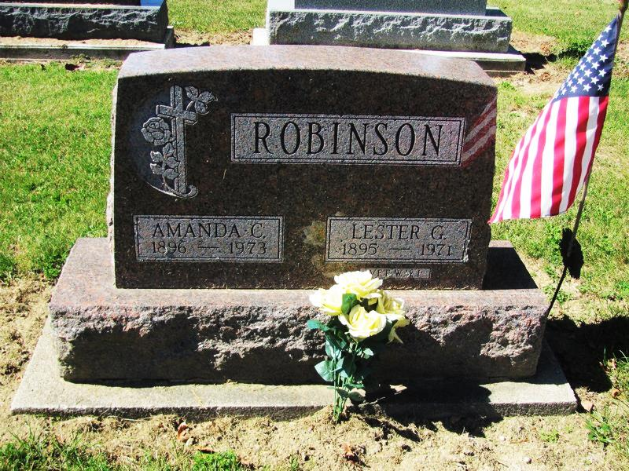
Photo by Jenna Langston

Adams Public Library System (Decatur, IN) online obit abstracts
Publication: Decatur Daily Democrat; Date: 24 DEC 1973
Title: Robinson, Amanda Catherine
Subject: Obituaries -- R -- 1970-1979
Abstract: Age: 77
Died: December 23, 1973
Notes: SBH - Pg. 40

