Stephen Joseph Sutton
March 18, 1941 – July 30, 2014
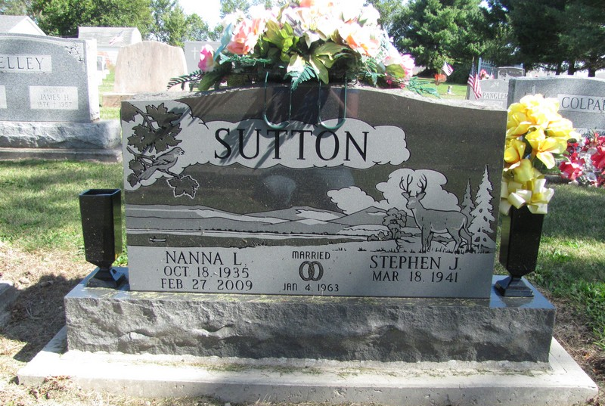
Photo by Jenna Langston

Stephen Joseph Sutton, 73, of Berne, IN, passed away at 10:35 PM on Wednesday, July 30, 2014, at Lutheran Hospital of Indiana, in Fort Wayne, IN. He was born on March 18, 1941, in Decatur, IN. He was married to Nanna Lee Aurand on Friday, January 04, 1963 in Indianapolis, IN. Stephen attended Decatur Catholic High School, and later went on to earn a bachelor’s degree from Tri-State University where he studied engineering. He had worked as an excavator for many years retiring from Dave’s Excavating in Marion, IN. In his spare time Stephen enjoyed hunting, trapping and cutting wood, he also was an avid gardener.
Survivors include: daughter - Jodi (husband, Tim) Roberts, Liberty Center, IN., son - Stephen (wife, Sandra) Sutton, Geneva, IN., son - Samuel Sutton, Geneva, IN., daughter - Sheri (husband, Richard) Hermann, Decatur, IN., son - Luke Sutton, Berne, IN., son - Kevin (wife, Judy) Fuhrman, Berne, IN., son - Gary Furhman, Fort Wayne, IN., sister - Susie (husband, Joseph) Iacovelli, Hillsdale, IL, sister - Sarah (husband, Tim) Jur, Cayce, SC., sister - Sharon (husband, John) Ryan, Indianapolis, IN., sister - Sandy (husband, Matthew) Mace, Rochelle, IL, 11 grandchildren, and 2 great-grandchildren.
He was preceded in death by his wife – Nanna Sutton, father - Jesse Cary Sutton, mother – Margaret Regina Sutton, daughter - Shauna Yoder, and 1 grandchild.
Family and friends may gather to share and remember at Downing & Glancy Funeral Home 100 N. Washington, Geneva, IN., on Monday, August 04, 2014 from 2:00 PM to 8:00 PM. There will be a Rosary Service beginning at 7:30 PM. Visitation will also be held from 9:00 AM to 10:00 AM on Tuesday, August 5, at the funeral home. In lieu of flowers the family has requested that donations be made to St. Mary of The Presentation Parish.
A service to celebrate Stephen’s life will be at St. Mary of the Presentation Catholic Church, located at 5970 E. 1100 S. Geneva, IN., at 10:30 AM on Tuesday, August 05, 2014 with Father J. Bosco Perrera officiating. Burial will follow in the St. Mary of the Presentation Parish Cemetery in Geneva.
Donations can be made to: St. Mary of The Presentation Parish, 5970 E. 1100 S., Geneva, IN 46740
Arrangements are being handled by Downing & Glancy Funeral Home in Geneva.
Downing & Glancy Funeral Home online obit (accessed August 1, 2014)

