Coleen F. Adler
July 7, 1941 – September 7, 2007

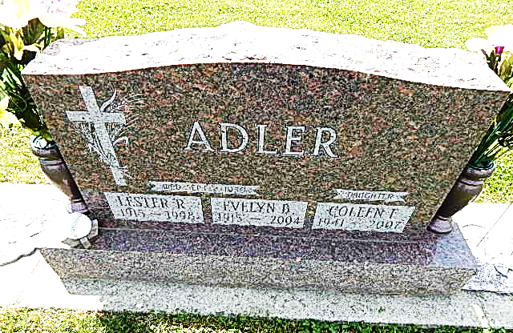
Photo by Alicia Kneuss

Coleen F. Adler, 66, of Connersville, Indiana formerly of Decatur, died on Friday, September 7, 2007 at the Lincoln Center Nursing Home in Connersville. She was the daughter of the late Lester & Evelyn (Reber) Adler. She was born July 7, 1941 in Adams County, Indiana.
Survivors are 2 sisters- her twin Kathleen Rodgers, Mrs. Dale (Wanda) Bieberich, a brother Dale Adler all of Decatur; 5 nephews, 3 nieces, 6 grandnieces and 3 grand nephews. Coleen attended Pleasant Dale Church of the Brethren in Decatur and worked in a factory.
Calling hours are from noon - 4:00 pm Sunday, September 9, 2007 at Haggard & Sefton Funeral Home and 1 hour prior to services at the church. Funeral service is at 11:00 am Monday, September 10th at Pleasant Dale Church of the Brethren, rural Decatur. Pastor Jay Carter will be officiating and burial is in Pleasant Dale Cemetery. Memorials are to Liberty House Assistance Fund.

Haggard-Sefton & Hirschy Funeral Home online obit (accessed September 8, 2007)

