Evelyn D. (Reber) Adler
March 17, 1915 – September 23, 2004

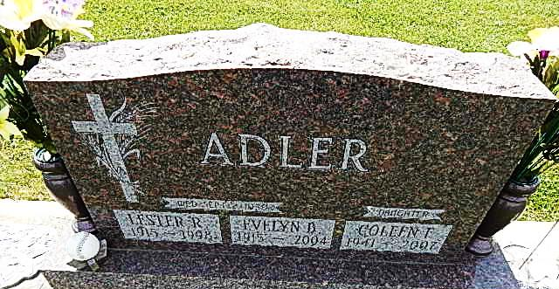
Photo by Alicia Kneuss

Evelyn B. Adler, 89

Evelyn B. Adler, 89, formerly of Decatur, died at Bluffton Regional Medical Center at 3:30 a.m. today, Sept. 23. Born in Adams County March 17, 1915 to Marion and Von Vera Baltzell Reber, her marriage to Lester Adler took place Sept. 2, 1939. He preceded her in death Aug. 14, 1998. A homemaker, she was formerly employed by General Electric in Decatur and Berco in Berne. She was a member of the Pleasant Dale Church of the Brethren and a member of the church’s Ladies Aid.
Survivors include a son, Dale, of Decatur; twin daughters Coleen Faye Adler, Connersville, and Kathleen Rodgers, Decatur; a third daughter, Mrs. Dale (Wanda) Bieberich, Decatur; a brother Chalmer Reber, Decatur; a sister, Mary Mabrey of Phoenix, Ariz.; eight grandchildren and seven great-grandchildren. Five brothers preceded her in death, Robert, Albert, Byron, Dean and Glen Reber.
Services at 2 p.m. Sunday will be held at Pleasant Dale Church of the Brethren with Rev. Jay Carter officiating. Burial will follow in the church cemetery. Calling from 6-8 p.m. Friday and 1-4 p.m. and 6-8 p.m. Saturday will be at Zwick & Jahn Funeral Home, Decatur.
Calling will also be held one hour prior to services Sunday at the church. Memorials may be made to the Pleasant Dale Church of the Brethren or to Family Hospice of Northeast Indiana.

Bluffton News Banner, Wells County, IN; September 25, 2004

